**Group 2 Assessment 1: Project Plan**

1. **Project management.**

GITHUB link: https://github.com/CP3407Group2/CP3407Group2.git

Group member and individual contributions

Miao Wenqiang: Write project description and the code of develop profile page.

Zhang Wenhao: Learn and use JAVA and GitHub. And write the code of the Login page.

Lei Jiayi: Write the code of mall information page and responsible for the Project development and release of ICT infrastructure part.

Liang Hao: Responsible for architectural design, database design and project planning, write the code of home page.

1. **Project description**

The history of shopping malls can be traced back to ancient times, when people traded through things like bazaars, street stalls and hawkers. With the development of urbanization and industrialization, modern shopping malls came into being. A shopping mall is usually a large building with various shops, supermarkets, restaurants and entertainment facilities inside. It is a place for shopping, entertainment and socializing. The establishment of these large shopping malls has greatly facilitated people's lives.

However, with the development of the Internet, many online shopping platforms have been born, such as Amazon, Taobao and so on. Online shopping has the convenience and product diversity that traditional stores cannot match, which leads more and more people to choose online shopping. This has brought a huge impact on the traditional sales industry. As a master of traditional sales, large shopping malls have also been impacted by online shopping, but compared with online shopping, large shopping malls still have their unique advantages. First of all, customers shopping in the mall can directly see and touch the products, and can feel their texture, appearance and size better. These direct feelings cannot be obtained in online shopping. Second, when shopping in the mall, customers can pick up the goods they purchased immediately, without waiting for several days or longer for express delivery. This is very important for some customers who are in urgent need of goods. Finally, the most important thing is that shopping in the mall can bring more social experience, and customers can interact with other customers and shop assistants. These interactions can allow customers to obtain more product information and shopping suggestions, and can also increase the fun of shopping.

There are many large shopping malls with huge scale and complicated internal structure. It is difficult for a consumer to find a desired certain type of product or to find a specific location store when shopping in such a mall. And because there is no unified information release platform, consumers are easy to miss various promotional activities and preferential information of shops. In addition to these, the underground parking lot of the shopping mall occupies a large area, and consumers often spend a lot of time and energy looking for their own cars, which affects the shopping experience.

Some shopping malls have their own map navigations, but they only provide navigation and do not integrate the information of the shopping malls. If shopping malls and information technology can be combined, it can bring customers a better shopping experience. The managers of large shopping malls have also gradually realized that if they want to resist the impact of online shopping on the physical industry and survive in the current complex and changeable shopping mode, they need to bring customers a better shopping experience. And this is inseparable from the support of information technology.

The smart shopping guide system can not only provide customers with basic location and navigation, but also display the stores in the mall and the types of goods they sell, which store in the mall has discount activities, so that customers can find the products they need more easily, and improve shopping experience. In addition to facing customers, for store owners, there is a channel for distributing product discount information to attract more customers and increase turnover. For shopping mall managers, through data analysis of customer shopping information, they can better understand customers' shopping habits and determine the direction of mall development. In conclusion, the smart shopping guide system is an essential ICT solution that can improve shopping mall efficiency and consumer satisfaction. We believe this project will bring great value to the mall and is expected to become the mainstream of shopping mall navigation systems in the future.

1. **Project Planning and scope**

Available days: 4 people. 56 days.

User story 1: Determine project selection. 1 day.

User story 2: Analyze existing programs and data. 3 days.

User story 3: Determine requirements: Collect user requirements, understand project background and objectives, and develop project plan and scope. 4 days.

User story 4: Planning and analysis: Detailed analysis and design of requirements, to determine the architecture and function of the software system, etc. 4 days.

User story 5: Write the requirements document. 1 days.

User story 6: Develop architectural models. 2days.

User story 7: Develop a prototype. 3 days.

User story 8: Design program testing. 2 days.

User story 9: Preliminarily write the front-end code. 5 days.

User story 10: Preliminarily write the back-end code. 5 days.

User story 11: Design and develop database. 3 days.

User story 12: Design and develop user interface. 4 days.

User story 13: First round of testing. 1 day.

User story 14: Improve the code. 5 days.

User story 15: Beautify the interface. 3 days.

User story 16: Second round of testing. 2 days.

User story 17: Deployment and distribution: Upload web pages to servers, configure and integrate various parts of the web page to ensure that the web page can be displayed and run properly in different devices and browsers. 3 days.

User story 18: Invite non-developers to test. 5 days.

1. **Project Design**
   1. Architectural design

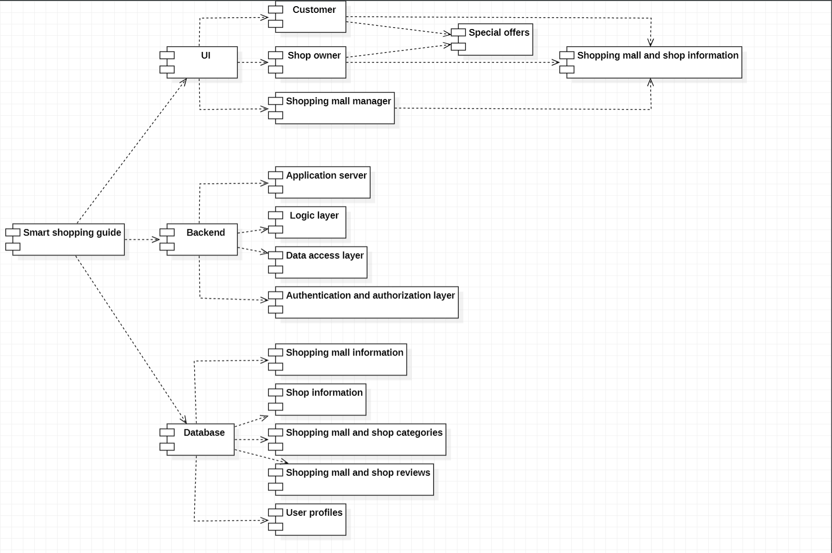

4.2 Database designs

4.2.1 Diagram

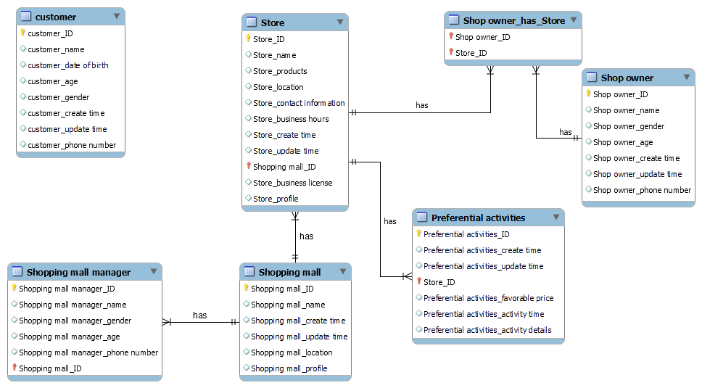

4.2.2 Code

-- MySQL Workbench Forward Engineering

SET @OLD_UNIQUE_CHECKS=@@UNIQUE_CHECKS, UNIQUE_CHECKS=0;

SET @OLD_FOREIGN_KEY_CHECKS=@@FOREIGN_KEY_CHECKS, FOREIGN_KEY_CHECKS=0;

SET @OLD_SQL_MODE=@@SQL_MODE, SQL_MODE='ONLY_FULL_GROUP_BY,STRICT_TRANS_TABLES,NO_ZERO_IN_DATE,NO_ZERO_DATE,ERROR_FOR_DIVISION_BY_ZERO,NO_ENGINE_SUBSTITUTION';

-- -----------------------------------------------------

-- Schema 3407_db

-- -----------------------------------------------------

-- -----------------------------------------------------

-- Schema 3407_db

-- -----------------------------------------------------

CREATE SCHEMA IF NOT EXISTS `3407_db` DEFAULT CHARACTER SET utf8 ;

USE `3407_db` ;

-- -----------------------------------------------------

-- Table `3407_db`.`customer`

-- -----------------------------------------------------

CREATE TABLE IF NOT EXISTS `3407_db`.`customer` (

`customer_ID` INT NOT NULL,

`customer_name` VARCHAR(45) NULL,

`customer_date of birth` VARCHAR(45) NULL,

`customer_age` VARCHAR(45) NULL,

`customer_gender` VARCHAR(45) NULL,

`customer_create time` DATETIME NULL,

`customer_update time` TIMESTAMP NULL,

`customer_phone number` VARCHAR(45) NULL,

PRIMARY KEY (`customer_ID`))

ENGINE = InnoDB;

-- -----------------------------------------------------

-- Table `3407_db`.`Shop owner`

-- -----------------------------------------------------

CREATE TABLE IF NOT EXISTS `3407_db`.`Shop owner` (

`Shop owner_ID` INT NOT NULL,

`Shop owner_name` VARCHAR(45) NULL,

`Shop owner_gender` VARCHAR(45) NULL,

`Shop owner_age` VARCHAR(45) NULL,

`Shop owner_create time` DATETIME NULL,

`Shop owner_update time` TIMESTAMP NULL,

`Shop owner_phone number` VARCHAR(45) NULL,

PRIMARY KEY (`Shop owner_ID`))

ENGINE = InnoDB;

-- -----------------------------------------------------

-- Table `3407_db`.`Shopping mall`

-- -----------------------------------------------------

CREATE TABLE IF NOT EXISTS `3407_db`.`Shopping mall` (

`Shopping mall_ID` INT NOT NULL,

`Shopping mall_name` VARCHAR(45) NULL,

`Shopping mall_create time` DATETIME NULL,

`Shopping mall_update time` TIMESTAMP NULL,

`Shopping mall_location` VARCHAR(45) NULL,

`Shopping mall_profile` TEXT NULL,

PRIMARY KEY (`Shopping mall_ID`))

ENGINE = InnoDB;

-- -----------------------------------------------------

-- Table `3407_db`.`Store`

-- -----------------------------------------------------

CREATE TABLE IF NOT EXISTS `3407_db`.`Store` (

`Store_ID` INT NOT NULL,

`Store_name` VARCHAR(45) NULL,

`Store_products` VARCHAR(45) NULL,

`Store_location` VARCHAR(45) NULL,

`Store_contact information` VARCHAR(45) NULL,

`Store_business hours` VARCHAR(45) NULL,

`Store_create time` DATETIME NULL,

`Store_update time` TIMESTAMP NULL,

`Shopping mall_ID` INT NOT NULL,

`Store_business license` VARCHAR(45) NULL,

`Store_profile` TEXT NULL,

PRIMARY KEY (`Store_ID`, `Shopping mall_ID`),

INDEX `fk_Store_Shopping mall1_idx` (`Shopping mall_ID` ASC) VISIBLE,

CONSTRAINT `fk_Store_Shopping mall1`

FOREIGN KEY (`Shopping mall_ID`)

REFERENCES `3407_db`.`Shopping mall` (`Shopping mall_ID`)

ON DELETE NO ACTION

ON UPDATE NO ACTION)

ENGINE = InnoDB;

-- -----------------------------------------------------

-- Table `3407_db`.`Preferential activities`

-- -----------------------------------------------------

CREATE TABLE IF NOT EXISTS `3407_db`.`Preferential activities` (

`Preferential activities_ID` INT NOT NULL,

`Preferential activities_create time` DATETIME NULL,

`Preferential activities_update time` TIMESTAMP NULL,

`Store_ID` INT NOT NULL,

`Preferential activities_favorable price` VARCHAR(45) NULL,

`Preferential activities_activity time` VARCHAR(45) NULL,

`Preferential activities_activity details` TEXT NULL,

PRIMARY KEY (`Preferential activities_ID`, `Store_ID`),

INDEX `fk_Preferential activities_Store1_idx` (`Store_ID` ASC) VISIBLE,

CONSTRAINT `fk_Preferential activities_Store1`

FOREIGN KEY (`Store_ID`)

REFERENCES `3407_db`.`Store` (`Store_ID`)

ON DELETE NO ACTION

ON UPDATE NO ACTION)

ENGINE = InnoDB;

-- -----------------------------------------------------

-- Table `3407_db`.`Shop owner_has_Store`

-- -----------------------------------------------------

CREATE TABLE IF NOT EXISTS `3407_db`.`Shop owner_has_Store` (

`Shop owner_ID` INT NOT NULL,

`Store_ID` INT NOT NULL,

PRIMARY KEY (`Shop owner_ID`, `Store_ID`),

INDEX `fk_Shop owner_has_Store_Store1_idx` (`Store_ID` ASC) VISIBLE,

INDEX `fk_Shop owner_has_Store_Shop owner_idx` (`Shop owner_ID` ASC) VISIBLE,

CONSTRAINT `fk_Shop owner_has_Store_Shop owner`

FOREIGN KEY (`Shop owner_ID`)

REFERENCES `3407_db`.`Shop owner` (`Shop owner_ID`)

ON DELETE NO ACTION

ON UPDATE NO ACTION,

CONSTRAINT `fk_Shop owner_has_Store_Store1`

FOREIGN KEY (`Store_ID`)

REFERENCES `3407_db`.`Store` (`Store_ID`)

ON DELETE NO ACTION

ON UPDATE NO ACTION)

ENGINE = InnoDB;

-- -----------------------------------------------------

-- Table `3407_db`.`Shopping mall manager`

-- -----------------------------------------------------

CREATE TABLE IF NOT EXISTS `3407_db`.`Shopping mall manager` (

`Shopping mall manager_ID` INT NOT NULL,

`Shopping mall manager_name` VARCHAR(45) NULL,

`Shopping mall manager_gender` VARCHAR(45) NULL,

`Shopping mall manager_age` VARCHAR(45) NULL,

`Shopping mall manager_phone number` VARCHAR(45) NULL,

`Shopping mall_ID` INT NOT NULL,

PRIMARY KEY (`Shopping mall manager_ID`, `Shopping mall_ID`),

INDEX `fk_Shopping mall manager_Shopping mall1_idx` (`Shopping mall_ID` ASC) VISIBLE,

CONSTRAINT `fk_Shopping mall manager_Shopping mall1`

FOREIGN KEY (`Shopping mall_ID`)

REFERENCES `3407_db`.`Shopping mall` (`Shopping mall_ID`)

ON DELETE NO ACTION

ON UPDATE NO ACTION)

ENGINE = InnoDB;

SET SQL_MODE=@OLD_SQL_MODE;

SET FOREIGN_KEY_CHECKS=@OLD_FOREIGN_KEY_CHECKS;

SET UNIQUE_CHECKS=@OLD_UNIQUE_CHECKS;

4.3 Interface design

4.3.1 Login page

The login screen of the mobile tour guide system for large shopping malls is used to login by filling in information such as account number, password, etc.

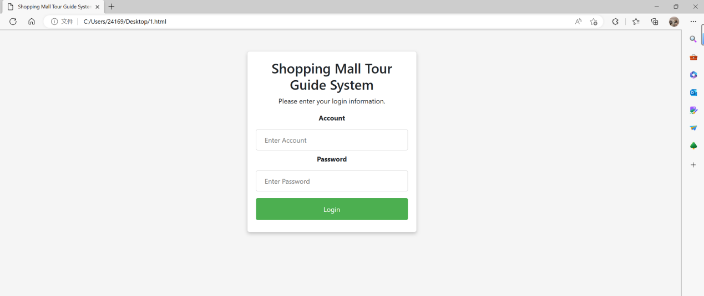

The code is as follows:

public Map<String, Object> success(Object o) {

Map<String, Object> map = new HashMap<>();

if (o == null) {

map.put("result", null);

return map;

}

if (o instanceof List) {

if (((List) o).size() == 1) {

o = ((List) o).get(0);

map.put("result", o);

}else {

String jsonString = JSONObject.toJSONString(o);

JSONArray objects = service.covertArray(JSONObject.parseArray(jsonString));

map.put("result", objects);

}

} else if (o instanceof Integer || o instanceof String) {

map.put("result", o);

} else {

String jsonString = JSONObject.toJSONString(o);

JSONObject jsonObject = JSONObject.parseObject(jsonString);

JSONObject j = service.covertObject(jsonObject);

map.put("result", j);

}

return map;

}

4.3.2 Home page

Home, allows viewing and operation of functional modules such as home page, bulletin board, product centre and mall information.

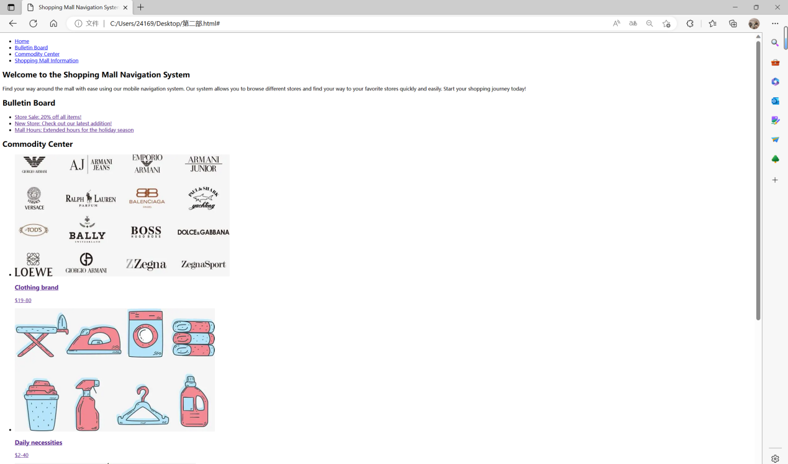

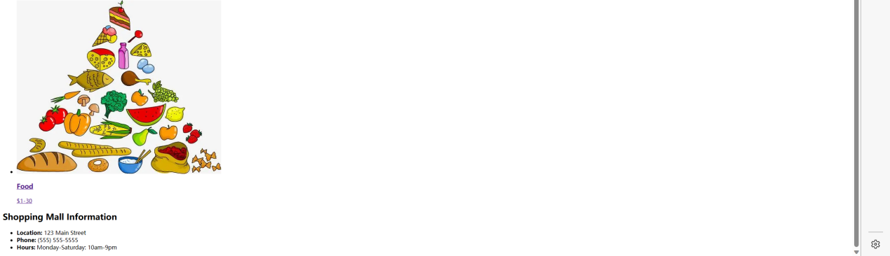

The code is as follows:

<!DOCTYPE html>

<html>

<head>

<title>Shopping Mall Navigation System</title>

<meta name="viewport" content="width=device-width, initial-scale=1.0">

<!-- Add any necessary CSS files -->

<link rel="stylesheet" type="text/css" href="style.css">

</head>

<body>

<header>

<!-- Add any necessary header elements, such as a logo or search bar -->

</header>

<nav>

<!-- Add a navigation menu for easy access to different sections of the website -->

<ul>

<li><a href="#home">Home</a></li>

<li><a href="#bulletin">Bulletin Board</a></li>

<li><a href="#commodity">Commodity Center</a></li>

<li><a href="#info">Shopping Mall Information</a></li>

</ul>

</nav>

<main>

<section id="home">

<!-- Add content for the home page -->

<h1>Welcome to the Shopping Mall Navigation System</h1>

<p>Find your way around the mall with ease using our mobile navigation system. Our system allows you to browse different stores and find your way to your favorite stores quickly and easily. Start your shopping journey today!</p>

</section>

<section id="bulletin">

<!-- Add a bulletin board with any relevant information -->

<h2>Bulletin Board</h2>

<ul>

<li><a href="#">Store Sale: 20% off all items!</a></li>

<li><a href="#">New Store: Check out our latest addition!</a></li>

<li><a href="#">Mall Hours: Extended hours for the holiday season</a></li>

</ul>

</section>

<section id="commodity">

<!-- Add a commodity center for browsing and purchasing items -->

<h2>Commodity Center</h2>

<ul>

<li>

<a href="#">

<img src="P1.png" alt="Item 1">

<h3>Clothing brand</h3>

<p>$19-80</p>

</a>

</li>

<li>

<a href="#">

<img src="P2.png" alt="Item 2">

<h3>Daily necessities</h3>

<p>$2-40</p>

</a>

</li>

<li>

<a href="#">

<img src="P3.png" alt="Item 3">

<h3>Food</h3>

<p>$1-30</p>

</a>

</li>

</ul>

</section>

<section id="info">

<!-- Add information about the shopping mall, such as location and hours -->

<h2>Shopping Mall Information</h2>

<ul>

<li><strong>Location:</strong> 123 Main Street</li>

<li><strong>Phone:</strong> (555) 555-5555</li>

<li><strong>Hours:</strong> Monday-Saturday: 10am-9pm

4.3.3 Profile page

The profile page allows users to view information such as personal details and to make changes and additions to their profile. In this example code, there's a form that includes fields for the person's name, email, address, phone number, and birthdate. The form also includes a "Save" button and a "Reset" button. When the user clicks the "Save" button, the form data would typically be submitted to a server-side script that could update the person's information in a database or other data store. The "Other Information" section of the page could include additional details about the person, such as their education, work history, hobbies, or interests. This section could be updated separately from the personal information form, depending on the needs of the application.

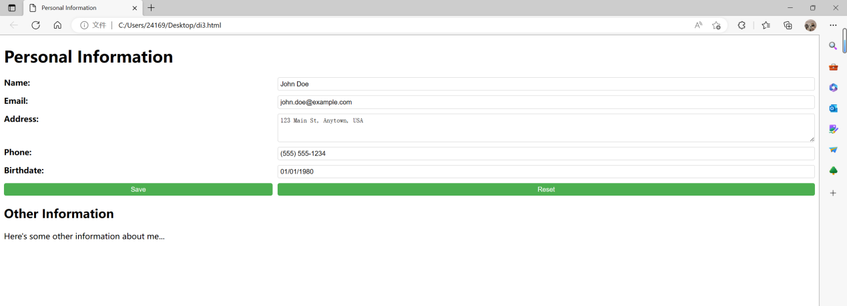

The code is as follows:

<!DOCTYPE html>

<html>

<head>

<title>Personal Information</title>

<meta charset="UTF-8">

<meta name="viewport" content="width=device-width, initial-scale=1.0">

<style>

form {

display: grid;

grid-template-columns: 1fr 2fr;

grid-gap: 10px;

margin-bottom: 20px;

}

label {

font-weight: bold;

}

input[type="text"], textarea {

width: 100%;

padding: 5px;

border: 1px solid #ccc;

border-radius: 4px;

box-sizing: border-box;

}

input[type="submit"], input[type="reset"] {

padding: 5px;

border-radius: 4px;

cursor: pointer;

background-color: #4CAF50;

color: white;

border: none;

}

input[type="submit"]:hover, input[type="reset"]:hover {

background-color: #3e8e41;

}

</style>

</head>

<body>

<h1>Personal Information</h1>

<form>

<label for="name">Name:</label>

<input type="text" id="name" name="name" value="John Doe">

<label for="email">Email:</label>

<input type="text" id="email" name="email" value="john.doe@example.com">

<label for="address">Address:</label>

<textarea id="address" name="address" rows="3">123 Main St, Anytown, USA</textarea>

<label for="phone">Phone:</label>

<input type="text" id="phone" name="phone" value="(555) 555-1234">

<label for="birthdate">Birthdate:</label>

<input type="text" id="birthdate" name="birthdate" value="01/01/1980">

<input type="submit" value="Save">

<input type="reset" value="Reset">

</form>

<h2>Other Information</h2>

<p>Here's some other information about me...</p>

</body>

</html>

4.3.4 Mall information page

A section where you can add the latest information about the mall. A section where users can enter keywords to search in sections of the page. Store details and price comparisons.

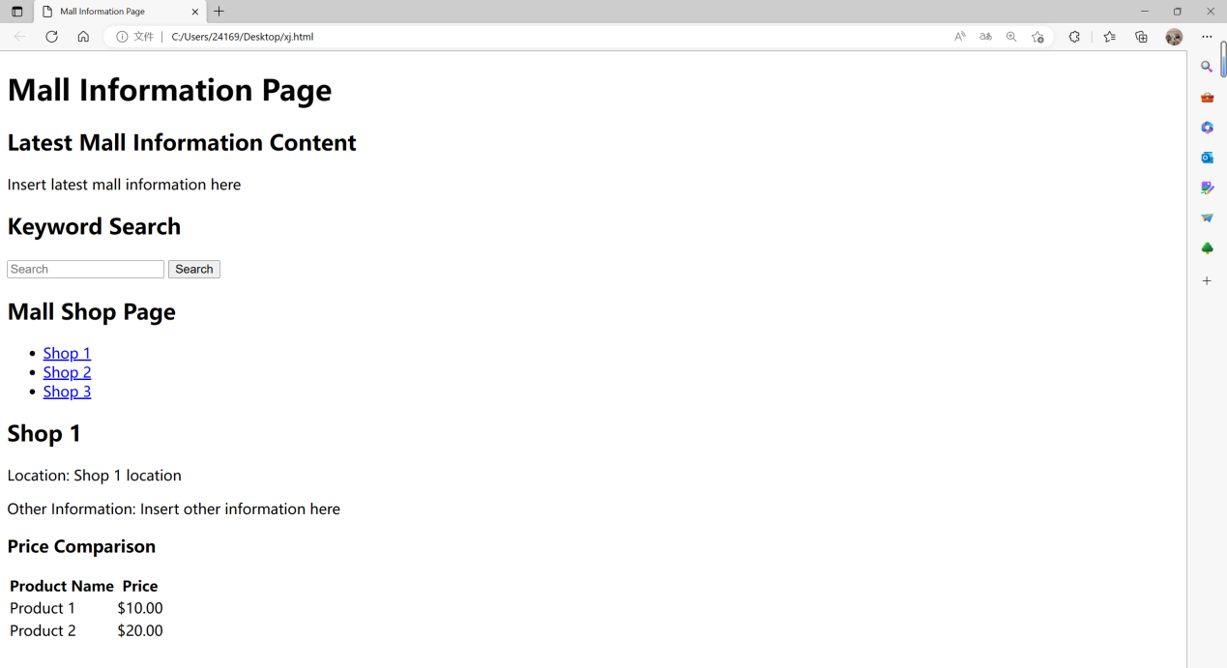

The code is as follows:

<!DOCTYPE html>

<html lang="en">

<head>

<meta charset="UTF-8" />

<meta name="viewport" content="width=device-width, initial-scale=1.0" />

<meta http-equiv="X-UA-Compatible" content="ie=edge" />

<title>Mall Information Page</title>

</head>

<body>

<header>

<h1>Mall Information Page</h1>

</header>

<!-- Latest Mall Information Content -->

<section>

<h2>Latest Mall Information Content</h2>

<p>Insert latest mall information here</p>

</section>

<!-- Keyword Search -->

<section>

<h2>Keyword Search</h2>

<input type="text" id="search" placeholder="Search" />

<button onclick="search()">Search</button>

</section>

<!-- Mall Shop Page -->

<section>

<h2>Mall Shop Page</h2>

<ul>

<li><a href="#shop1">Shop 1</a></li>

<li><a href="#shop2">Shop 2</a></li>

<li><a href="#shop3">Shop 3</a></li>

<!-- add more shops as needed -->

</ul>

</section>

<!-- Shop Details and Price Comparison -->

<section id="shop1">

<h2>Shop 1</h2>

<p>Location: Shop 1 location</p>

<p>Other Information: Insert other information here</p>

<h3>Price Comparison</h3>

<table>

<tr>

<th>Product Name</th>

<th>Price</th>

</tr>

<tr>

<td>Product 1</td>

<td>$10.00</td>

</tr>

<tr>

<td>Product 2</td>

<td>$20.00</td>

</tr>

<!-- add more products as needed -->

</table>

</section>

<!-- add more sections for other shops as needed -->

<script>

function search() {

const query = document.getElementById("search").value.toLowerCase();

const sections = document.getElementsByTagName("section");

for (let i = 0; i < sections.length; i++) {

const section = sections[i];

const sectionTitle = section.querySelector("h2").textContent.toLowerCase();

if (sectionTitle.includes(query)) {

section.style.display = "block";

} else {

section.style.display = "none";

}

}

}

</script>

</body>

</html>

1. **Project development and release ICT infrastructure**

5.1 Programming languages

JAVA

Java is a general-purpose programming language that is designed to be platform-independent, meaning that programs written in Java can run on different operating systems and hardware platforms without the need for any modifications.

Java is an object-oriented language that is known for its simplicity, ease of use, and robustness. It is widely used in developing web-based applications, mobile applications, desktop applications, and even games.

Java programs are typically compiled into bytecode, which is a highly optimized and platform-independent format. This bytecode is then executed by the Java Virtual Machine (JVM), which translates it into machine code that can run on the specific operating system and hardware platform.

One of the key features of Java is its extensive standard library, which includes a wide range of classes and methods for performing common programming tasks such as input/output, networking, database access, and graphical user interface (GUI) development. Additionally, Java has a large and active community of developers who contribute to open source libraries and frameworks that further simplify and accelerate software development in Java.

5.2 Source code repositories (Configuration Management)

GitHub

GitHub is a web-based platform that provides a version control system for managing and collaborating on software development projects. It allows users to store and manage their source code, track changes made to the code over time, and collaborate with other developers on projects.

GitHub uses the Git version control system, which is a distributed version control system that allows multiple developers to work on the same codebase simultaneously without interfering with each other's work. With GitHub, developers can create repositories to store their code and make it available to other users. They can also collaborate on projects by forking repositories, creating branches, and merging changes back into the main codebase.

In addition to version control, GitHub also provides features such as bug tracking, project management, code review, and continuous integration and deployment. It is widely used by individuals and organizations for software development, both in open source and private projects.

GitHub has a large and active community of users who contribute to open source projects and share their code with others. This has made it a popular platform for discovering new projects, learning from other developers, and contributing to the open source community.

5.3 Project collaboration tools

Zoom

Zoom is a popular video conferencing software that supports online video conferencing, voice conferencing, screen sharing, online chat and other functions, and is widely used in telecommuting, online education, telemedicine and other fields.

5.4 development tools

5.4.1 MySQL

MySQL is a popular open source relational database management system (RDBMS) that is widely used in web application development, data storage, business applications, and other fields.

The following are some of the main features of MySQL:

1.Open source and free: MySQL is an open source software, users can use and modify its source code for free.

2.Cross-platform support: MySQL supports multiple operating systems, including Linux, Windows, Mac OS, etc.

3.High Performance: MySQL has efficient query and read/write performance and can handle large amounts of data.

4.Security: MySQL provides powerful security features, including data encryption, user access control, and more.

5.Scalability: MySQL can easily scale to handle more data and traffic, and can use technologies such as replication and partitioning.

6.Standardization: MySQL follows SQL standards and is easy to use and manage.

When using MySQL, you need to learn the SQL language in order to manage the database. SQL is a structured query language for retrieving, inserting, updating, and deleting data from the database. MySQL provides many commands and functions to work with data, including creating tables, adding data, querying data, updating.

5.4.2 Java

5.4.3 HTML

HTML (HyperText Markup Language) is a markup language used to create web pages. HTML uses tags and attributes to describe different elements on a web page, such as text, images, links, tables, etc. HTML tags are keywords surrounded by "<" and " >" surrounded by keywords, which are used to define the structure and content of a document and tell the browser how to display the web page.